52 Animation
Animation 2
Chapters 3
General Principles and Tools 3
The Graph Editor 3
The Action Editor 3
Animation Techniques 3
Animating Deformation 3
Drivers 3
Animation Fundamentals 3
Animation Editors 4
Categories 4
Key Frames 4
Adding Key Frames 5
Removing Key Frames 5
Editing Key Frames 5
Keyframe Visualization 5
Motion Paths 5
Options 7
Actions 8
F-Curve Interpolation 9
Basic Animation 9
Insert Keyframes 9
Auto Keyframe 10
Keying Sets 10
Properties 11
Editing 12
Working with Actions 12
Drivers 12
Drivers Panel 13
Driver Settings 13
Driver Variables 14
Workflow 15
UI 15
Expression 16
Copy Paste 16
Transform Driver 16
Examples 17
Driver Expression 17
Orbit a point 18
Driver Namespace 18
Shape Key Driver 18
Drivers And Multiple Relative Shape Keys 19
Troubleshooting 25
Scripted Expression 25
Rotational Properties are Radians 25
Intra-armature Bone Drivers Can Misbehave 25
See Also 26
Links 26
Keying Sets 26
Keying Set Panel 26
Active Keying Set Panel 27
Adding Properties 29
Markers 29
Pose markers 30
Visualization 30
Standard 30
Sequencer 30
3D View 30
Creating and Editing Markers 31
Creating Markers 31
Selecting Markers 31
Naming Markers 31
Moving Markers 32
Duplicating Markers 32
Deleting Markers 32
Using Constraints in Animation 32
Controlling Animation with Constraints 33
Example 33
Animating Constraints Influence 34
Shape Keys 34
Shape Keys Panel 35
Relative Shape Keys 36
Absolute Shape Keys 37
Workflow For Relative Shape Keys 38
Workflow For Absolute Shape Keys 39
More Details On Absolute Shape Keys 42
Shape Key Operators 43
Animating Cameras 43
Switching Cameras 43
Moving Cameras 44
Move Along a Path 44
Fly/Walk Modes 44
Lock Camera to View 44
Dolly Zoom 44
Moving Objects on a Path 44
Parenting Method 45
The Follow Path Constraint 45
The Clamp To Constraint 46

Animation

Animation is making an object move or change shape over time. Objects can be animated in many ways:
Moving as a whole object
Changing their position, orientation or size in time;
Deforming them
Animating their vertices or control points;
Inherited animation
Causing the object to move based on the movement of another object (e.g. its parent, hook, armature, etc...).
In this chapter we will cover the first two, but the basics given here are actually vital for understanding the following chapters as well.
Animation is typically achieved with the use of Key Frames.

Chapters

General Principles and Tools
- Key frames
- Using The Timeline
- Markers

The Graph Editor
- F-Curves
- F-Curve Editing
- F-Curve Modifiers

The Action Editor
- Actions
- Working with Actions

Animation Techniques
- Constraints
- Moving objects on a Path
- Game Engine Physics Recording

Animating Deformation
- Shape Keys
- Deforming by a Lattice
- Deforming with Hooks
See also Hook Modifier

Drivers
- Drivers
- Driven Shape Keys
The Introduction to Character Animation tutorial is a good starting point for learning character animation. Even if you never used Bforartists before.

Animation Fundamentals
Actions
Actions are used to record the animation of objects and properties.
Drivers
Drivers are used to control and animate properties.
Keying Sets
Keying Sets are used to record a set of properties at the same time.
Markers
Markers are used to mark key points/events within an animation.
Motion Paths
Motion Paths are used to visualize an animation.
Shape Keys
Shape Keys are used to deform objects into new shapes.

Animation Editors
Timeline
The Timeline Editor is a quick editor to set and control the time frame. This also has some tools for animation.
Graph Editor
The Graph Editor is mostly used to edit the F-Curves and Keyframes for Channels and Drivers.
Dope Sheet
The Dopes Sheet contains a collection of animation editors.
NLA Editor
The NLA Editor is used to edit and blend Actions together.

Categories
Modifiers
Modifiers are automatic operations that affect an object in a non-destructive way. With modifiers, you can perform many effects automatically that would otherwise be tedious to do manually.
Rigging
Rigging.
Constraints
Constraints are a way of connecting transform properties (position, rotation and scale) between objects.
Physical Simulation
This category covers various advanced Bforartists effects, often used to simulate real physical phenomena. There is the Particle System for things like hair, grass, smoke, flocks. Soft Bodies are useful for everything that tends to bend, deform, in reaction to forces like gravity or wind. Cloth simulation, to simulate clothes or materials. Rigid Bodies can simulate dynamic objects that are fairly rigid. Fluids, which include liquids and gasses, can be simulated, including Smoke. Force Fields can modify the behavior of simulations.
Motion Tracking
Motion tracking is a new technique available in Bforartists. It is still under development, and currently supports basic operations for 2D motion tracking, 3D motion tracking, and camera solution.
Animation Scripts
Add-on scripts for animation.
Rigging Scipts
Add-on scripts for rigging.

Key Frames

A Key Frame is simply a marker in time which stores the value of a property.
For example, a key frame might indicate that the horizontal position of a cube is at 3m on frame 1.
The purpose of a key frame is to allow for interpolated animation, meaning, for example, that the user could then add another key on frame 10, specifying the cube’s horizontal position at 20m, and Bforartists will automatically determine the correct position of the cube for all the frames between frame 1 and 10 depending on the chosen interpolation method (e.g. linear, bezier, quadratic, etc...).

Adding Key Frames
There are several methods of adding new keys. Namely:
- In the 3D View, pressing I will bring up a menu to choose what to add a key frame to.
- Hovering over a property and pressing I.
- RMB a value and choose Insert Keyframe from the menu.

Removing Key Frames
There are several methods of removing key frames
- In the 3D View press Alt-I to remove keys on the current frame for selected objects.
- When the mouse is over a value press Alt-I.
- RMB a value and choose Delete Keyframe from the menu.

Editing Key Frames
For editing key frames go to the Graph Editor or to the Dopesheet

Keyframe Visualization

There are some important visualization features in the 3D views that can help animation.
When the current frame is a keyframe for the current active object, the name of this object (shown in the bottom left corner of the 3D views) turns yellow.
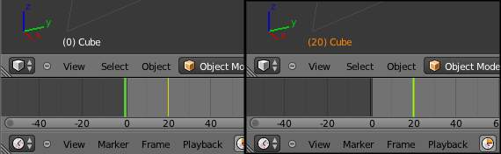

Left: Current frame at 0. Right: Current frame is a keyframe for Cube

Motion Paths
Reference
Mode: Object mode
Panel: Object

This feature allows you to visualize the animation of objects by displaying their position over a series of frames.
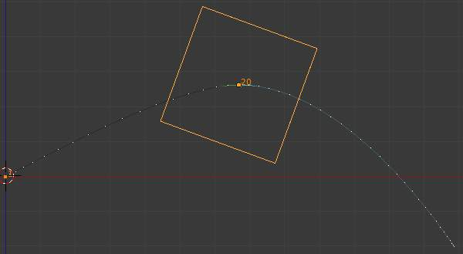
An animated cube with its motion path displayed
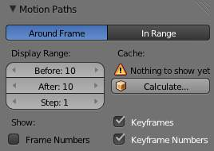

Motion paths panel
Before we look at its options (all regrouped in the same Visualisations panel, in the Editing context, let’s first see how to display/hide these paths. You have to do it manually - and you have to first select the objects you want to show/hide the motion paths. Then,
- To show the paths (or update them, if needed), click on the Calculate Path button.
- To hide the paths, click on the Clear Paths button
Remember: only selected object and their paths are affected by these actions!
The paths are drawn in black with white dots indicating frames, and a blue glow around the current frame.

Options
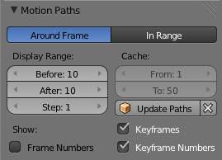

The Motion Paths Panel set to “Around Frame”
Around Frame
Around Frame, Display Paths of poses within a fixed number of frames around the current frame. When you enable this button, you rather get paths for a given number of frames before and after the current one (again, as with ghosts).
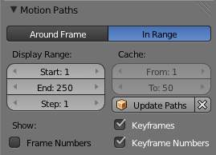

The Motion Paths Panel set to “In Range”
In Range
In Range, Display Paths of poses within specified range.
Display Range
Before/After
Number of frames to show before and after the current frame (only for ‘Around Current Frame’ Onion-skinning method)
Start/End
Starting and Ending frame of range of paths to display/calculate (not for ‘Around Current Frame’ Onion-skinning method)
Step
This is the same thing as the GStep for ghosts - it allows you the only materialize on the path one frame each n ones. Mostly useful when you enable the frame number display (see below), to avoid cluttering the 3D views.
Frame Numbers
When enabled, a small number appears next to each frame dot on the path, which is of course the number of the corresponding frame...
Keyframes
When enabled, big yellow square dots are drawn on motion paths, materializing the keyframes of their bones (i.e. only the paths of keyed bones at a given frame get a yellow dot at this frame).
Keyframe Numbers
When enabled, you’ll see the numbers of the displayed keyframes - so this option is obviously only valid when Show Keys is enabled.
Cache
From / To
These are the start/end frames of the range in which motion paths are drawn. You cannot modify this range without deleting the motion path first.
Calculate Paths/ Update Paths
If no paths have been calculated, Calculate Paths will create a new motion path in cache. In the pop up box, select the frame range to calculate. If a path has already been calculated, Update Paths will update the path shape to the current animation. To change the frame range of the calculated path, you need to delete the path and calculate it again.

Actions

When animating objects and properties in Bforartists, Actions record and contain the data.
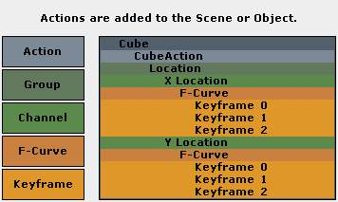
Actions.
So when you animate an object by changing its location with keyframes, the animation is saved to the Action.
Each property has a channel which it is recorded to, for example, Cube.location.x is recorded to Channel X Location.
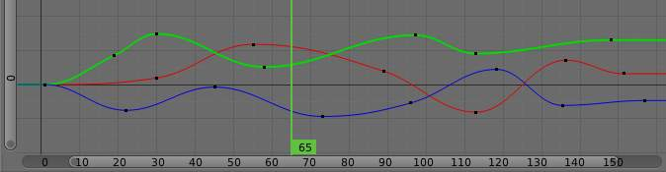
Graph Editor. Each Channel has an F-Curve represented by the lines between the keyframes.
Actions
Record and contain animation data.
Groups
Are groups of channels.
Channels
Record properties.
F-Curves
Are used to interpolate the difference between the keyframes.
Keyframes
Are used to set the values of properties.

F-Curve Interpolation
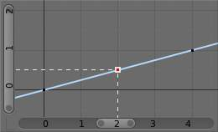
Graph Editor: Channel F-Curve.
The keyframes are set values by the user.
The F-Curve is used to interpolate the difference between the keyframes.
The F-Curve has different types of interpolation and also F-Curve Modifiers.
Most the settings for the F-Curve are found in the Graph Editor.

Basic Animation
These are some common ways to animate objects. These methods can be used on different objects, like armature bones in pose mode.

Insert Keyframes
This example shows you how to animate a cubes location, rotation, and scale.
- First, in the Timeline, or other animation editors, set the frame to 1.
- With the Cube selected in Object Mode, press I in the 3D View.
- From the Insert Keyframe Menu select LocRotScale.
- This will record the location, rotation, and scale, for the Cube on frame 1.
- Set the frame to 100.
- Use Grab/Move G, Rotate R, Scale S, to transform the cube.
- Press I in the 3D View. From the Insert Keyframe Menu select LocRotScale.
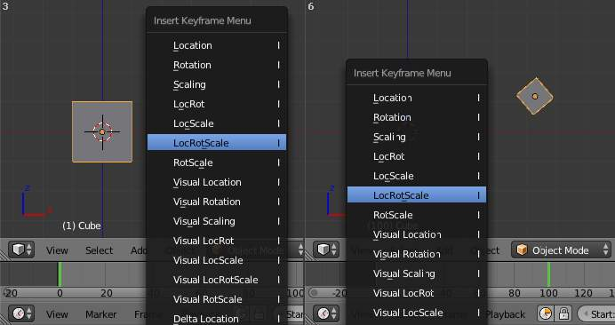
Insert Keyframes.
To test the animation, press Alt-A to play.
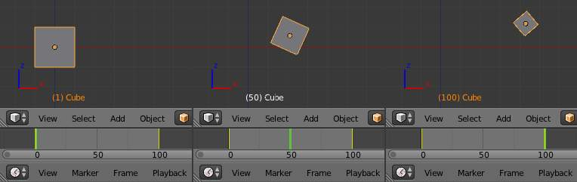
The animation on frames 1, 50, 100.

Auto Keyframe
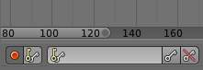
Timeline Auto Keyframe.
Auto Keyframe is the red record button in the Timeline header. Auto Keyframe adds keyframes automatically to the set frame if the value for transform type properties changes.
See Timeline V Keyframe Control for more info.

Keying Sets
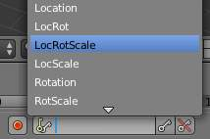
Timeline Keying Sets.
Keying Sets are a set of keyframe channels. They are used to record multiple properties at the same time. There are some built in keying sets, ‘LocRotScale’, and also custom keying sets can be made.
To use the keying set, first select a keying set from the Timeline header, or the Keying Sets Panel.
Now when you press I in the 3D view, Bforartists will add keyframes for all the properties in the active keying set.
See Keying Sets for more info.

Properties
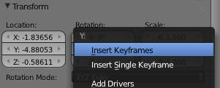
Keyframe properties.
Keyframes can be used to animate lots of different properties in Bforartists. To add keyframes to a property in the UI, RMB the property, then select Insert Single Keyframe, or Insert Keyframes. Insert Keyframes I will add a keyframes for the set of properties.
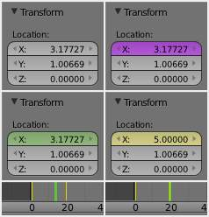
Properties, Drivers, Keyframes.
Properties have different colors and menu items for different states.
Gray - Property is not animated with Keyframes or Drivers.
Insert Keyframes I. Insert Single Keyframe. Add Drivers. Add Single Driver. Paste Driver.
Purple - Property value is controlled with a Driver.
Delete Drivers. Delete Single Driver. Copy Driver. Paste Driver.
Green - Property has Channel with Keyframes.
Insert Keyframes I. Insert Single Keyframe. Clear Keyframes Alt-Shift-I Clear Single Keyframes.
Yellow - Property has Keyframes on the current Frame.
Replace Keyframes I. Replace Single Keyframe. Delete Keyframes Alt-I. Delete Single Keyframe. Clear Keyframes Alt-Shift-I Clear Single Keyframes.
Each property also has some Keying Set options.
Add All to Keying Set K. Add Single to Keying Set. Remove from Keying Set.

Editing
3D View.
Insert Keyframes on current frame I Delete Keyframes on current frame Alt-I

Working with Actions
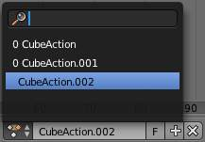
Action Browser.
When you first animate an object by adding keyframes, Bforartists creates an Action to record the data.
Actions can be managed with the Action Browser in the DopeSheet Action Editor header, or the properties region of the NLA Editor.
If you are making multiple actions for the same object, press the F button for each action, this will give the actions a Fake User and will make Bforartists save the unlinked actions.
Objects can only use one Action at a time for editing, the NLA Editor is used to blend mutiple actions together.

Drivers

Graph Editor: Driver example.
Drivers can use properties, numbers, transformations, and scripts, to control the values of properties.
Using a F-Curve, the driver reads the value of the Driver Value and sets the value of the selected property it was added to.
So from this example, if the Driver Value is 2.0 the property will be 0.5.
The Driver Value is determined by Driver Variables or a Scripted Expression.
Most the settings for the drivers F-Curves are found in the Graph Editor.

Drivers Panel
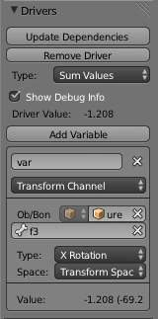
Graph Editor: Drivers: Drivers Panel.
This panel is located in the Graph Editor with the mode set to Drivers.
The drivers panel is for setting up Driver Variables or a Scripted Expression which will determine the value of the Driver Value.

Driver Settings
Update Dependencies
This will force an update for the Driver Value dependencies.
Remove Driver
Removes the driver from the object.
Type
The type of calculation to use on the set of Driver Variables. (If you only have one driver variable there is no real difference between average, sum, minimum and maximum)
Average Value
Uses the average value of the referenced Driver Variables.
Sum Values
Uses the sum of the referenced Driver Variables.
Scripted Expression
Uses a Scripted Expression. See Expr. You must write a python expression which performs your own calculations on the Driver Variables.
Minimum Value
Uses the lowest value from the referenced Driver Variables.
Maximum Value
Uses the highest value from the referenced Driver Variables.
Expr
Scripted Expression. Here you can add real numbers, math operators, math functions, python properties, driver functions. See Driver Expression below for some examples.
Show Debug Info
Shows the Driver Value. The current value of the variables or scripted expression.
Add Variable
Adds a new Driver Variable.
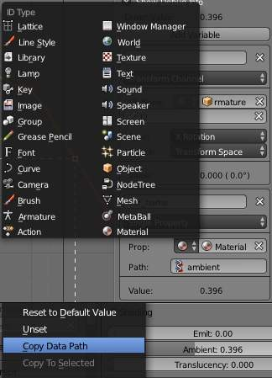
Setup of a Single Property.
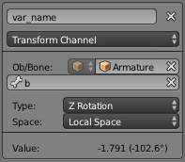  Transform Channel Setup | 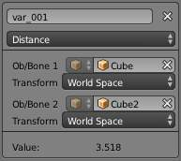  Distance Setup

Driver Variables
Name
Name to use for scripted expressions/functions. No spaces or dots are allowed and must start with a letter.
Variable Type
The type of variable to use.
Single Property
Use the value from some RNA property. For example, the Ambient shading color from a material. First select the type of ID-block, then the ID of the ID-block, then copy and paste an RNA property (Ctrl+V).
ID-Type
The ID-Block type, example, Key, Image, Object, Material.
ID
The ID of the ID-Block type, example, Material.001.
RNA Path
The RNA id name of the property, example, ‘ambient’ from material shading.
Transform Channel
Use one of the Transform channels from an object or bone.
ID
ID of the object, example, Cube, Armature, Camera.
Bone
ID of the Armature bone, example, Bone, Bone.002, Arm.r. This option is for armatures.
Type
Example, X Location, X Rotation, X Scale.
Space
World Space, Transform Space, Local Space.
Rotational Difference
Use the rotational difference between two objects or bones.
Distance
Use the distance between two objects or bones.
Value
Shows the value of the variable.

Workflow
There are some different ways to add drivers in Bforartists. These are some driver examples and workflow. After adding drivers they are usually modified in the Graph Editor with the mode set the Drivers.

UI
The common way to add a driver to a property is to right click a property, then add a driver via the context menu.
Add Drivers
This will add drivers to the set of properties related to the selected one. For example, it will add drivers to X, Y, and Z for Rotation.
Add Single Driver
This will add a single driver to the selected property.
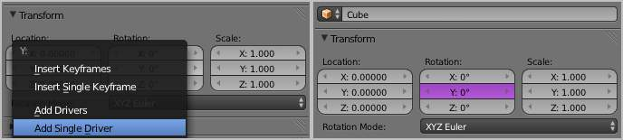
Drivers can also be added by pressing D with the mouse over the property set.

Expression
This is quick way to add drivers with a scripted expression. First click the property you want add a driver to, then add a hash # and a scripted expression.
Some examples.
- #frame
- #frame / 20.0
- #sin(frame)
- #cos(frame)

Copy Paste
Drivers can be copied and pasted in the UI, via the context menu. When adding drivers with the same settings, this can save time modifying settings.

Transform Driver
This examples shows you how setup a transform driver. First make sure you are in the Front Ortho view. Numpad5, Numpad1.
- In object mode, select then duplicate the default Cube. Shift-D. Move Cube.001 to a new location.
- With Cube.001 selected, add a single driver to the Rotation Y property.
- Open the Graph Editor, set the Mode to Drivers.
- Show Only Selected is useful disabled for drivers, marked green in the picture.
- In the channels region, select the Y Euler Rotation property.
- Press N to open the properties region, scroll down to Drivers panel.
- Change the Type to Averaged Value, this will return the averaged value of the driver variables.
- Modify the driver variable settings.
- Type - Transform Channel
- Ob/Bone - Cube
- Transform Type - X Location
- Transform Space - World Space
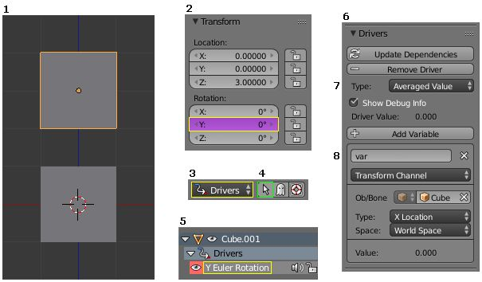
When finished, Cube.001 should rotate on the Y axis when moving Cube left of right.

Examples
Some Driver Examples.

Driver Expression
Here are some examples using the scripted expression Expr to set the Driver Value.
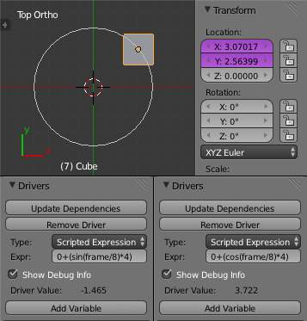
Object Rotation.

Orbit a point
Here two drivers have been added to the Cube, X Location and Y Location.
The scripted expressions are being used to set the object location.
X Location Expr
0 + (sin(frame / 8) * 4)
(frame/8) : is the current frame of the animation, divided by 8 to slow the orbit down. (sin( )*4) : This returns the sine of (frame/8), then multiplies by 4 for a bigger circle. 0 + : is used to control the X Location offset of the orbit.
Y Location Expr
0 + (cos(frame / 8) * 4)
(frame / 8) : is the current frame of the animation, divided by 8 to slow the orbit down. (cos( ) * 4) : This returns the cosine of (frame/8), then multiplies by 4 for a bigger circle. 0 + : is used to control the Y Location offset of the orbit.
frame is the same as bpy.context.scene.frame_current.

Driver Namespace
There is a list of built in driver functions and properties. These can be displayed via the python console.
>>> bpy.app.driver_namespace['
__builtins__']
__doc__']
__loader__']
__name__']
__package__']
acos']
acosh']
asin']
asinh']
atan']
atan2']
atanh']
bpy']
ceil']
copysign']
cos']
cosh']
..
This script will add a function to the driver namespace, which can then be used in the expression driver_func(frame)
import bpy

def driver_func(val):
return val * val # return val squared

# add function to driver_namespace
bpy.app.driver_namespace['driver_func'] = driver_func

Shape Key Driver
This example is a Shape Key Driver. The driver was added to the shape key Value.
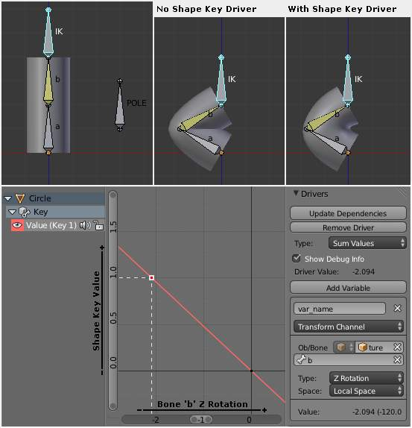
Shape Key Driver. Click to enlarge.
This example uses the Armature Bone ‘b’ Z Rotation to control the Value of a Shape Key. The bone rotation mode is set to XYZ Euler.
The Driver F-Curve is mapped like so
Bone Z Rotation 0.0(0.0): Shape Key value 0.0 Bone Z Rotation -2.09(-120.0): Shape Key value 1.0
This kind of driver can also be setup with the Variable Type Rotational Difference.
See Shape Keys for more info.

Drivers And Multiple Relative Shape Keys
The following screenshots illustrate combining shape keys, bones, and drivers to make multiple chained relative shape keys sharing a single root. While it lacks the convenience of the single Evaluation Time of an absolute shape key, it allows you to have more complex relationships between your shape keys.
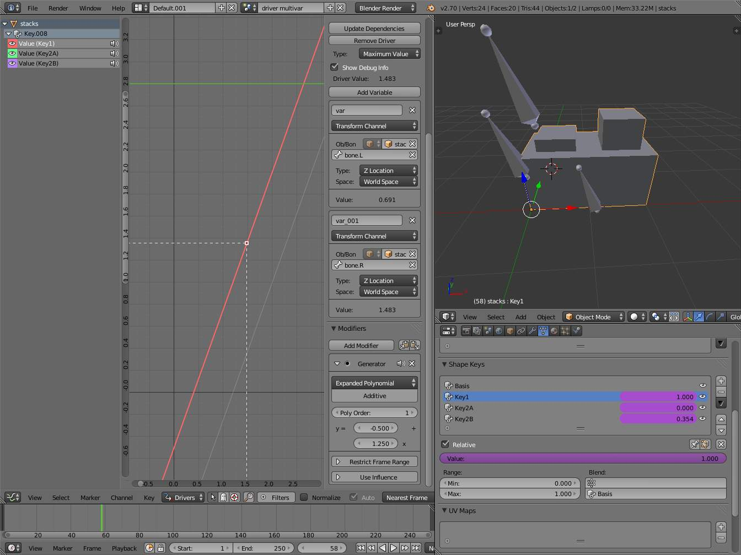
Key1 must handle conflicting values from the two bones
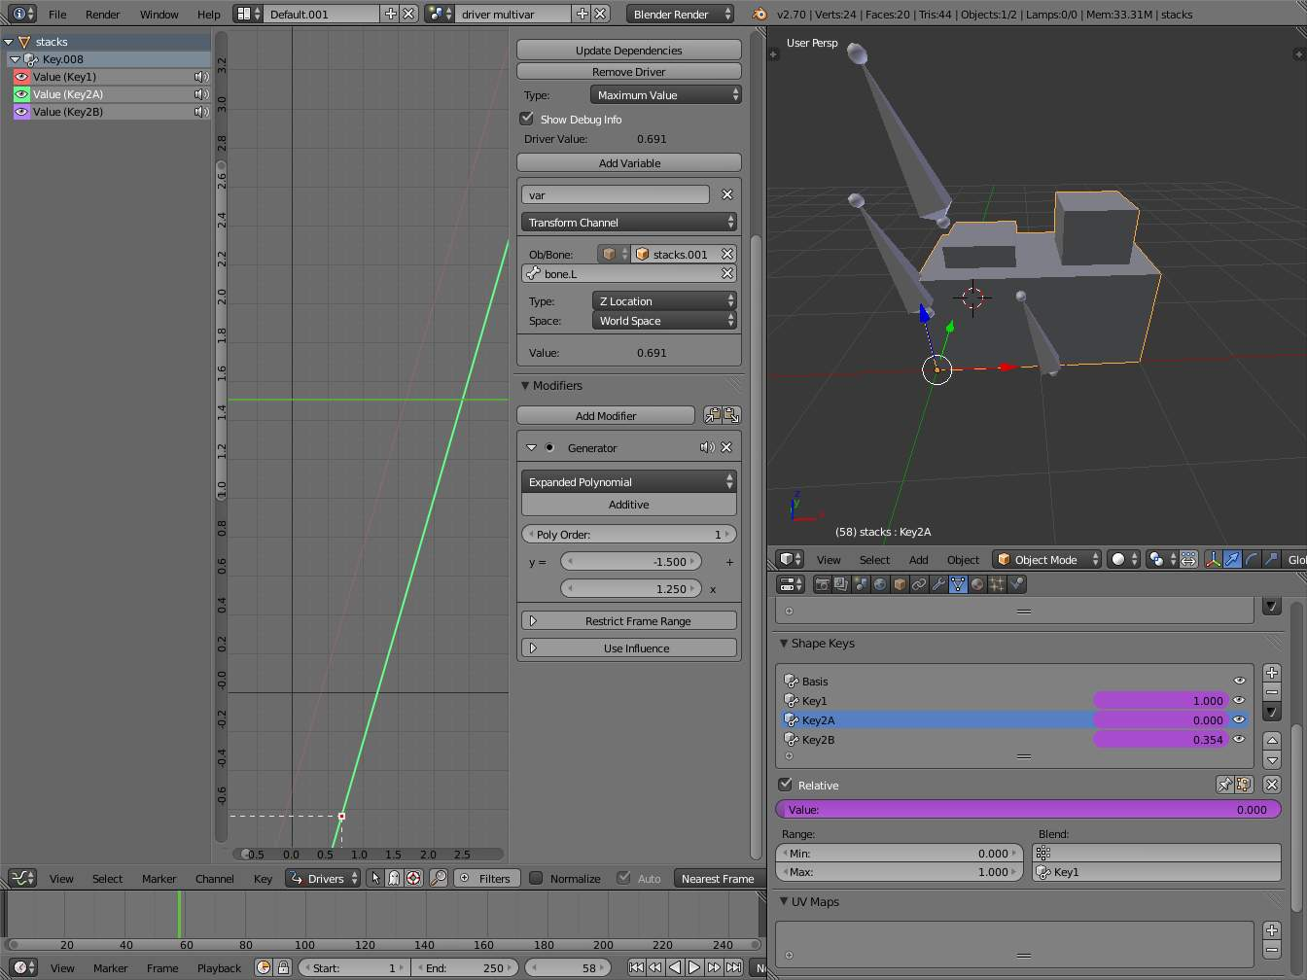
Key2A has different generator coefficients so it is activated in a different range of the bone’s position.
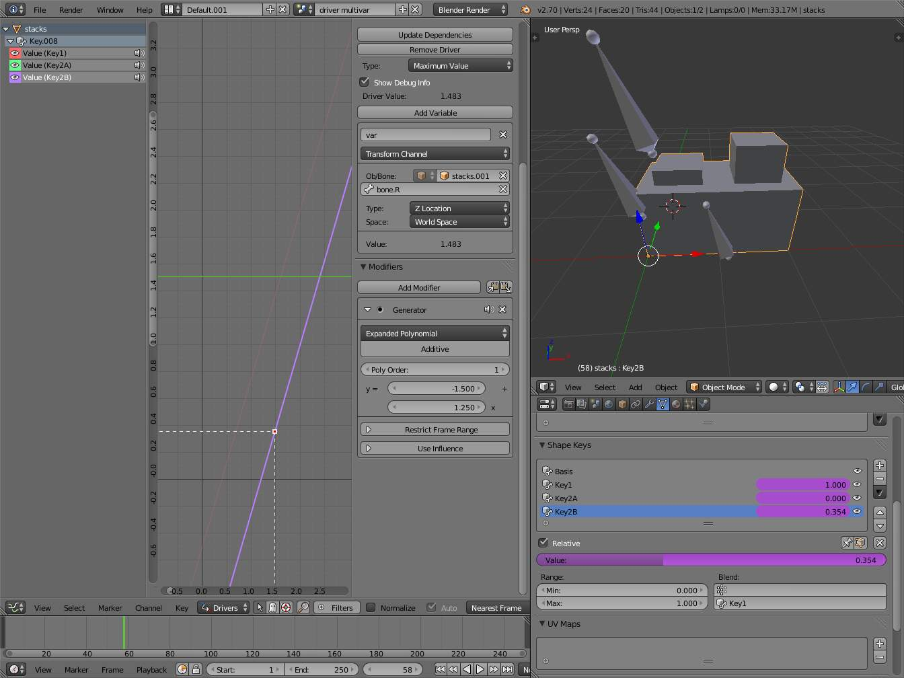
Key2B is the same as Key2A, but is controlled by the second bone.
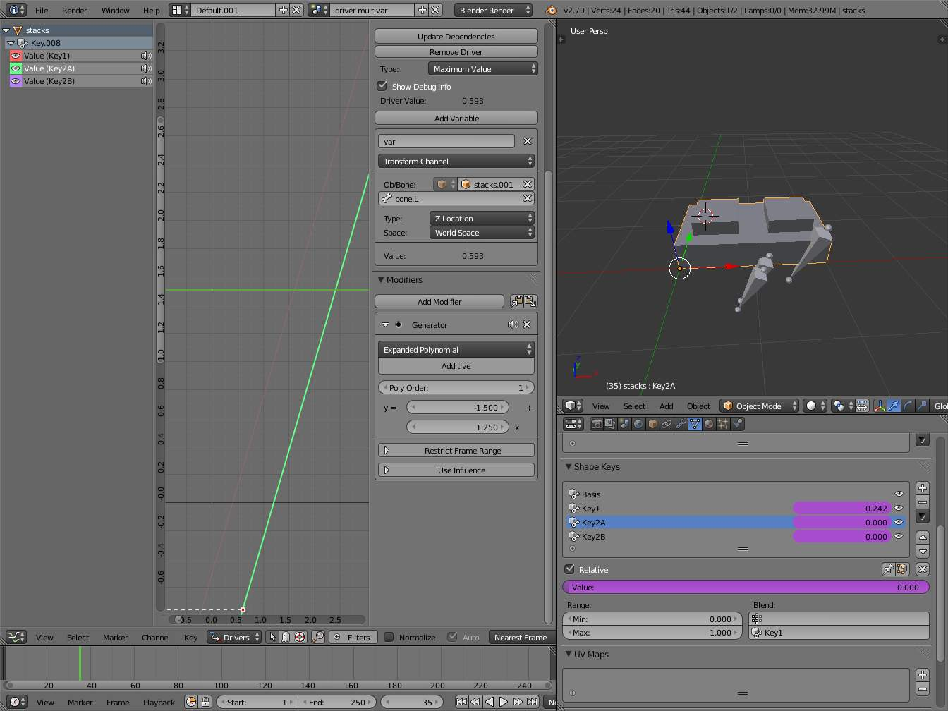
when both bones are low, Key2B and Key2A are deactivated and Key1 is at low influence.
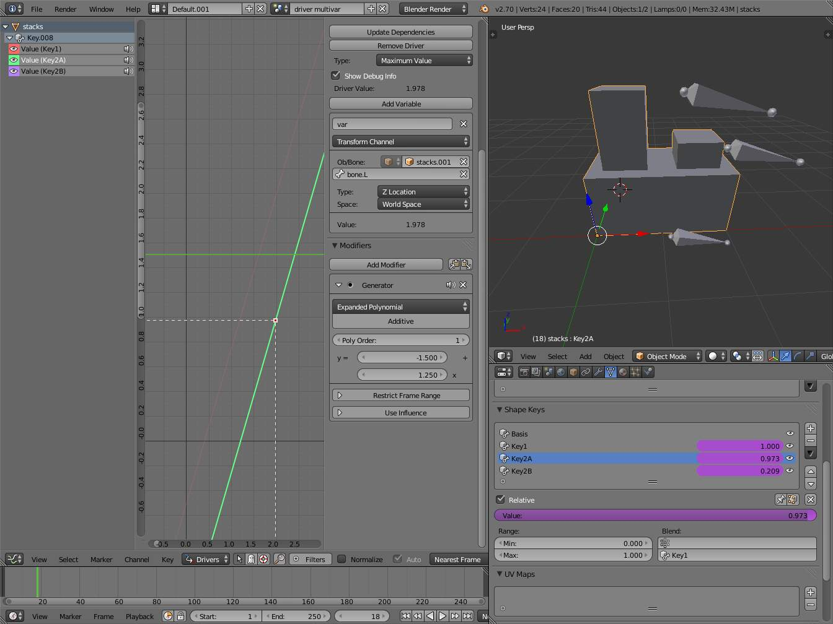
The Basis shape key has the stacks fully retracted. Key1 has the base fully extended. Key2A has the left stack fully extended. Key2B has the right stack fully extended. Key2A and Key2B are both relative to Key1 (as you can see in the field in the bottom right of the Shape Keys panel.
The value of Key1 is bound to the position of bones by a driver with two variables. Each variable uses the world Z coordinate of a bone and uses the maximum value to determine how much the base should be extended. The generator polynomial is crafted such that the top of the dominant stack should line up with the bone for that stack.
The value of Key2A is bound to the position of Bone.L. Its generator parameters are crafted such that when Key1’s value reaches 1, the value of Key2A starts increasing beyond zero. In this way the top of the left stack will move with bone.L (mostly).
The value of Key2B is bound to the position of Bone.R. Its generator parameters are similar to Key2A so that the top of the right stack will move with bone.R (mostly).
Since it’s quite easy for bone.L and bone.R to be in positions that indicate conflicting values for Key1 there will be times when the bones do not line up with the tops of their respective stacks. If the driver for Key1 were to use Average or Minimum instead of Maximum to determine the value of the shape key then “conflicts” between bone.L and bone.R would be resolved differently. You will chose according to the needs of your animation.

Troubleshooting
Some common problems people may run in to when using drivers.

Scripted Expression
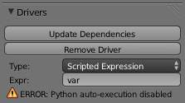
Graph Editor > Properties > Drivers.
Info Header.
By default Bforartists will not auto run python scripts.
If using a Scripted Expression Driver Type, you will have to open the file as Trusted Source, or set Auto Run Python Scripts in User Preferences > File > Auto Execution.
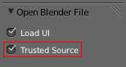
File Browser.
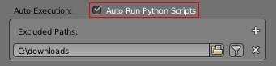
User Preference > File > Auto Execution.

Rotational Properties are Radians
Parts of the User Interface may use different units of measurements for angles, rotation. In the Graph Editor while working with Drivers, all angles are Radians.

Intra-armature Bone Drivers Can Misbehave
There is a well known limitation with drivers on bones that refer to another bone in the same armature. Their values can be incorrectly calculated based on the position of the other bone as it was before you adjust the current_frame. This can lead to obvious shape glitches when the rendering of frames has a jump in the frame number (either because the .blend file is currently on a different frame number or because you’re skipping already-rendered frames).

See Also
- Animation
- Graph Editor
- F-Curves
- Extending Bforartists with Python.

Links
- Python and its documentation.
- functions.wolfram.com

Keying Sets

Timeline Keying Sets.
Keying Sets are a collection of properties. They are used to keyframe multiple properties at the same time, usually by pressing I in the 3D View.
There are some built in Keying Sets, and also custom Keying Sets called Absolute Keying Sets.
To select and use a Keying Set, set the Active Keying Set in the Timeline Header, or the Keying Set Panel, or press Ctrl-Alt-Shift-I in the 3D View.

Keying Set Panel
This panel is used to add, select, manage Absolute Keying Sets.
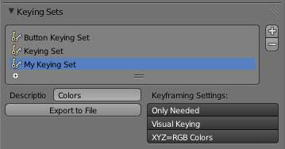
Properties > Scene > Keying Set Panel.
Keying Set Name
The active Keying Set is highlighted in blue, press Ctrl-LMB to rename.
+
Add new (Empty) keying set to the active Scene.
-
Remove the active Keying Set.
Active Keying Set properties
Description
A short description of the keying set.
Export to File
Export Keying Set to a python script File.py. To re add the keying set from the File.py, open then run the File.py from the Text Editor.
Keyframing Settings
These options control all properties in the Keying Set. Note, the same settings in User Preferences override these settings if enabled.
Only Needed
Only insert keyframes where they’re needed in the relevant F-Curves.
Visual Keying
Insert keyframes based on the visual transformation.
XYZ=RGB Colors
For new F-Curves, set the colors to RGB for the property set, Location XYZ for example.

Active Keying Set Panel
This panel is used to add properties to the active Keying Set.
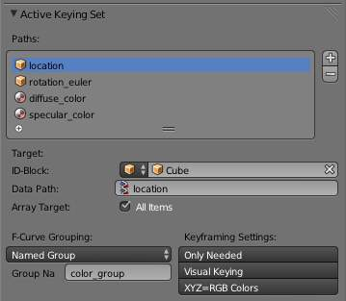
Properties > Scene > Active Keying Set Panel.
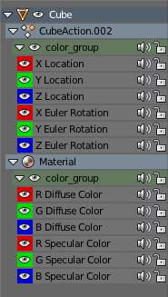
Properties > Graph Editor > Channels, Named Group.
Paths
A collection of Paths each with a Data Path to a property to add to the active Keying Set. The active Path is highlighted in blue.
- Add new empty path to active Keying Set.
- Remove active path from the active Keying Set.
Active Path properties
ID-Block
Set the ID-Type + Object ID Data Path for the property.
Data Path
Set the rest of the Data Path for the property.
Array Target
Use All Items from the Data Path or select the array index for a specific property.
F-Curve Grouping
This controls what Group to add the Channels to. Keying Set Name, None, Named Group.
Keyframing Settings
These options control individual properties in the Keying Set.
Only Needed
Only insert keyframes where they’re needed in the relevant F-Curves.
Visual Keying
Insert keyframes based on the visual transformation.
XYZ=RGB Colors
For new F-Curves, set the colors to RGB for the property set, Location XYZ for example.

Adding Properties
Some ways to add properties to keying sets.
RMB the property in the User Interface, then select Add Single to Keying Set or Add All to Keying Set. This will add the properties to the active keying set, or to a new keying set if none exist.
Hover the mouse over the properties, then press K, to add Add All to Keying Set.

Markers

Markers are used to denote frames at which something significant happens - it could be that a character’s animation starts, the camera changes position, or a door opens, for example. Markers can be given names to make them more meaningful at a quick glance. They are available in many of Bforartists’s windows, under different forms. Unlike the keyframes, markers are always placed at a whole frame number, you cannot e.g. set a marker at “frame 2.5 ”.
Markers can be created and edited in all of the following editors (including their different modes):
- The Graph Editor Window.
- The Action Editor window.
- The The Dope Sheet.
- The NLA Editor window.
- The Video Sequence Editor window.
- The Timeline window.When you create
A marker created in one of these windows will also appear in all others that support them, including:
- The 3D View window.

Pose markers
There is another type of markers, called “pose markers”, which are specific to the armatures and the Action Editor window. They are related to the pose libraries, and are discussed in detail here.

Visualization

Standard
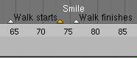
Markers: small but useful.
Most of the window types visualize markers the same way: as small triangles at their bottom, white if unselected or yellow if selected.
If they have a name, this is shown to their right, in white when the marker is selected. See (Markers: small but useful).

Sequencer
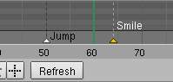
Markers in the Sequencer
The Video Sequence Editor just adds a vertical dashed line to each marker (gray if the marker is unselected, or white if it’s selected).

3D View
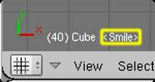
Marker in a 3D View.
The View do not allow you to create/edit/remove markers, they just show their name between <> at there bottom left corner, near the active object’s name, when you are at their frame (see Marker in a 3D view).

Creating and Editing Markers
Unfortunately, there is no common shortcuts and menu for marker’s editing, across the different window types that supports them... So in the refboxes of each action described below, I put the most-common shortcut and menu entry, with the known exceptions between brackets.

Creating Markers
Reference
Mode: all modes
Menu: Marker ‣ Add Marker (Frame ‣ Add Marker in a timeline)
Hotkey: M (Ctrl-Alt-M in a VSE)

The simplest way to add a marker is to move to the frame where you would like it to appear, and press M (or Ctrl-Alt-M in a video sequence editor).
Alternatively, you can press Alt-A (or the “playback” button of the Timeline window) to make the animation play, and then press M (or Ctrl-Alt-M in VSE) at the appropriate points. This can be especially useful to mark the beats in some music.

Selecting Markers
Reference
Mode: all modes
Hotkey: RMB, Shift-RMB, A / Ctrl-A, B / Ctrl-B

Click RMB on the marker’s triangle to select it. Use Shift-RMB to (de)select multiple markers.
In the Ipo Curve Editor, Action Editor, NLA Editor and Video Sequence Editor windows, you can also (de)select all markers with Ctrl-A, and border-select them with Ctrl-B (as usual, LMB to select, RMB to deselect). The corresponding options are found in the Select menu of these windows.
In the Timeline and Audio windows, you can (de)select all markers with A , and border (de)select them with B ...

Naming Markers
Reference
Mode: all modes
Menu: Marker ‣ (Re)Name Marker ( Frame ‣ Name Marker in a timeline)
Hotkey: Ctrl-M

Having dozens of markers scattered throughout your scene’s time won’t help you much unless you know what they stand for. You can name a marker by selecting it, pressing Ctrl-M, typing the name, and pressing the OK button.

Moving Markers
Reference
Mode: all modes
Menu: Marker ‣ Grab/Move Marker ( Frame ‣ Grab/Move Marker in a timeline)
Hotkey: Ctrl-G ( G in a timeline or audio)

Once you have one or more markers selected, press Ctrl-G (or G in Timeline or Audio windows) to move them, and confirm the move with LMB or Return (as usual, cancel the move with RMB, or Esc).
By default, you grab the markers in one-frame steps, but if you hold Ctrl, the markers will move in steps corresponding to one second (according to the scenes FPS).

Duplicating Markers
Reference
Mode: all modes
Menu: Marker ‣ Duplicate Marker ( Frame ‣ Duplicate Marker in a timeline)
Hotkey: Ctrl-Shift-D ( Shift-D in a timeline or audio)

You can duplicate the selected markers by pressing Ctrl-Shift-D (or Shift-D in a Timeline or Audio window). Once duplicated, the new ones are automatically placed in grab mode, so you can move them where (or rather when) you want.
Note that unlike most other duplications in Bforartists, the names of the duplicated markers are not altered at all (no .001 numeric counter append...).

Deleting Markers
Reference
Mode: all modes
Menu: Marker ‣ Delete Marker ( Frame ‣ Delete Marker in a timeline)
Hotkey: Shift-X ( X in a timeline or audio)

To delete the selected marker(s) simply press Shift-X (or X in a Timeline or Audio’’ window), and confirm the pop-up message with LMB.

Using Constraints in Animation

Constraints are a way to control an object’s properties (its location/rotation/scale), using either plain static values (like the “limit” ones), or (an)other object(s), called “targets” (like e.g. the “copy” ones).
Even though these constraints might be useful in static projects, their main usage is obviously in animation. There are two different aspects in constraints’ animation:
- You can control an object’s animation through the targets used by its constraints (this is a form of indirect animation).
- You can animate constraints’ settings

Controlling Animation with Constraints
This applies only to constraints using target(s). Indeed, these targets can then control the constraint’s owner’s properties, and hence, animating the targets will indirectly animate the owner.
This indirect “constraint” animation can be very simple, like for example with the Copy Location constraint, where the owner object will simply copy the location of its target (with an optional constant offset). But you can also have very complex behaviors, like when using the Action constraint, which is a sort of Animation Driver for actions!
We should also mention the classical Child Of constraint, which creates parent/child relationship. These relationships indeed imply indirect animation (as transforming the parent affects by default all its children). But the Child Of constraint is also very important, as it allows you to parent your objects to bones, and hence use Armatures to animate them!
Back to our simple Copy Location example, you can have two different behaviors of this constraint:
- When its Offset button is disabled (the default), the location of the owner is “absolutely” controlled by the constraint’s target, which means nothing (except other constraints below in the stack...) will be able to control the owner’s position. Not even the object’s animation curves.
- However, when the Offset button is enabled, the location of the owner is “relatively” controlled by the constraint’s target. This means that location’s properties of the owner are offset from the location of the target. And these owner’s location properties can be controlled e.g. by its Loc... curves (or actions, or NLA...)!

Example
Let’s use the Copy Location constraint and its Offset button. For example, you can make your owner (let’s call it moon) describe perfect circles centered on the (0.0, 0.0, 0.0) point (using e.g. pydriven LocX / LocY animation curves, see this page), and then make it copy the location of a target (called, I don’t know... earth, for example) - with the Offset button enabled. Congratulation, you just modeled a satellite in a (simplified) orbit around its planet... Just do the same thing with its planet around its star (which you might call sun, what do you think?), and why not, for the star around its galaxy...
Here is a small animation of a “solar” system created using (among a few others) the technique described above:
https://vimeo.com/15187945
Note that the this “solar” system is not realistic at all (wrong scale, the “earth” is rotating in the wrong direction around the “sun”, ...).
You can download the .blend file (download here) used to create this animation.

Animating Constraints Influence
More “classically”, you can also animate a few properties of each constraint using animation curves.
You only have two animation curves (see also: Graph Editor):
- You can animate the Influence of a constraint. For example, in the Example above, I used it to first stick the camera to the “moon”, then to the “earth”, and finally to nothing, using two Copy Location constraints with Offset set, and their Influence cross-fading together...
- More anecdotal, you can also, for some constraints using an armature’s bone as target, animate where along this bone (between root and tip) lays the real target point (0.0 means “full-root”, and 1.0, “full-tip”).

Shape Keys

Shape Keys are used on Objects like Mesh, Curve, Surface, Lattice. They are used to deform the object vertices into a new shape.
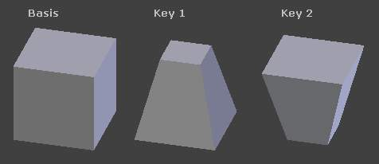
A mesh with different shape keys applied.
There are two types of Shape Keys.
Relative
Which are relative to the Basis or selected shape key. They are mainly used as, for limb joints, muscles, or Facial Animation.
Absolute
Which are relative to the previous and next shape key. They are mainly used to deform the objects into different shapes over time.
The shape key data, the deformation of the objects vertices, is usually modified in the 3D View by selecting a shape key, then moving the object vertices to a new position.

Shape Keys Panel
Reference
Mode: All modes
Panel: Properties, Object Data, Shape Keys

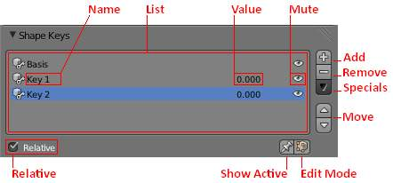
Shape Keys. Options.
Relative
Set the shape keys to Relative or Absolute.
Name
Name of the Shape Key.
Value
Current Value of the Shape Key (0.0 to 1.0).
Mute
This visually disables the shape key in the 3D view.
Add
Add a new shape key to the list.
Remove
Remove a shape key from the list.
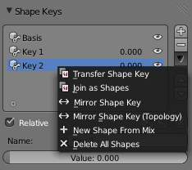
Shape Keys Specials.
Specials
A menu with some operators.
Transfer Shape Key
Transfer the active ‘Shape Key’ from a different object. Select two objects, the active Shape Key is copied to the active object.
Join as Shapes
Transfer the ‘Current Shape’ from a different object. Select two objects, the Shape is copied to the active object.
Mirror Shape Key
If your mesh is nice and symmetrical, in Object Mode, you can mirror the shape keys on the X axis. This won’t work unless the mesh vertices are perfectly symmetrical. Use the Mesh ‣ Symmetrize function in Edit Mode.
Mirror Shape Key (Topology)
This is the same as Mirror Shape Key though it detects the mirrored vertices based on the topology of the mesh. The mesh vertices dont have to be perfectly symmetrical for this one to work.
New Shape From Mix
Add a new shape key with the current deformed shape of the object.
Delete All Shapes
Delete all shape keys.
Move
Move shape key up or down in the list.
Show Active
Show the shape of the active shape key in the 3D View. Show Active is enabled while the object is in Edit Mode, unless the setting below is enabled.
Edit Mode
Modify the shape key settings while the object is in Edit mode.

Relative Shape Keys
Relative shape keys deform from a selected shape key. By default all relative shape keys deform from the first shape key called the Basis shape key.
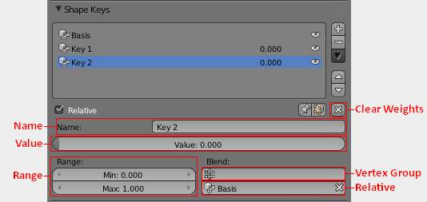
Relative Shape Keys. Options.
Clear Weights
Set all values to 0.
Name
Name of the active shape key.
Value
Value of the active shape key.
Range
Min and Max range of the active shape key value.
Vertex Group
Limit the active shape key deformation to a vertex group.
Relative
Select the shape key to deform from.

Absolute Shape Keys
Absolute shape keys deform from the previous and to the next shape key. They are mainly used to deform the object into different shapes over time.
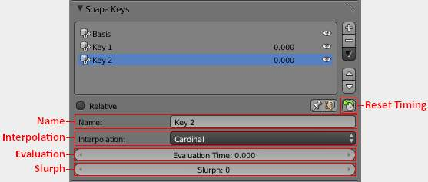
Absolute Shape Keys. Options.
Reset Timing
Reset the timing for absolute shape keys. For example, if you have the shape keys, Basis, Key_1, Key_2, in that order.
Reset Timing will loop the shapekeys, and set the shape key frames to +0.1.
Basis 0.1 Key_1 0.2 Key_2 0.3
Evaluation Time will show this as frame*100.
Basis 10.0 Key_1 20.0 Key_2 30.0
Name
Name of the active shape key.
Interpolation
This controls the interpolation between shape keys.
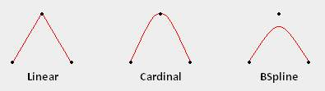
Different types of interpolation.
Evaluation Time
This is used to control the shape key influence.
For example, if you have the shape keys, Basis, Key_1, Key_2, in that order,and you reset timing.
Basis 10.0 Key_1 20.0 Key_2 30.0
You can control the shape key influence with Evaluation Time. Here keyframes have been used to control Evaluation Time for animation.
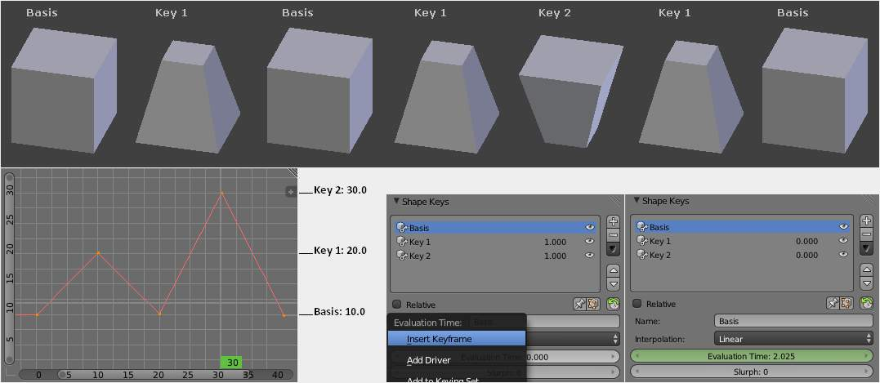
Animation with Evaluation Time.

Workflow For Relative Shape Keys
This example shows you how to make a cube mesh transform in to a sphere.
- In Object Mode add two shape keys via the Shape Key Panel.
- Basis is the rest shape. Key 1 will be the new shape.
- With Key 1 selected, switch to Edit Mode.
- Press Shift-Alt-S To Sphere, move the mouse right, then LMB.
- Switch to Object Mode.
- Set the Value for Key 1 to see the transformation between the shape keys.
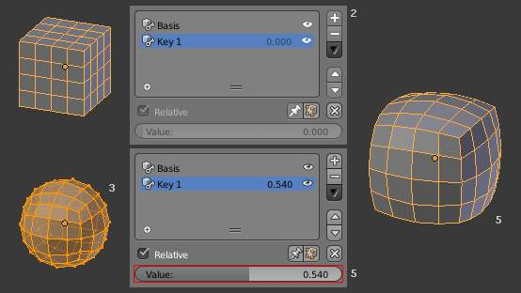
Shape Key workflow.

Workflow For Absolute Shape Keys
- Select the default Cube.
- Switch to Edit Mode.
- Switch to Face Select mode (if you are not already in it)
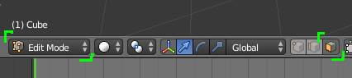
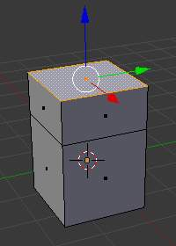
- Select the top face.
- Extrude up E 1 LMB.
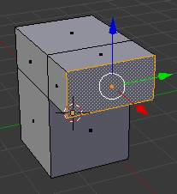
- Select a side face on the top half. (the one at x=1 if possible)
- Extrude out E 1 LMB.
- Switch back to Object Mode.
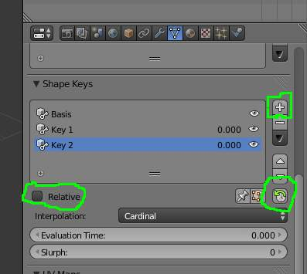
- Add a basis shape keys and two more via the + button on the Shape Key Panel.
- Uncheck the Relative checkbox.
- Click the Reset Timing button.
- Switch to Edit Mode.
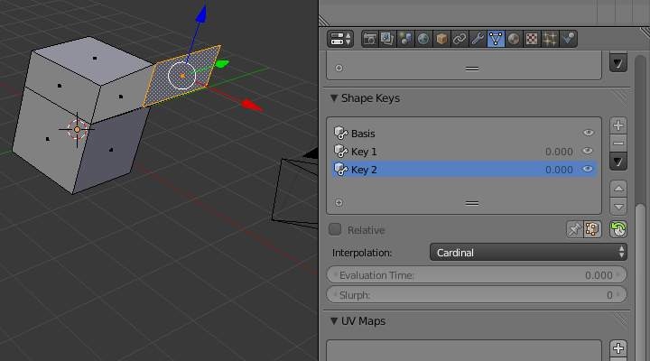
- Select shape key Key 2 to edit the third shape key.
- Select the extruded side face and G Z 1 LMB
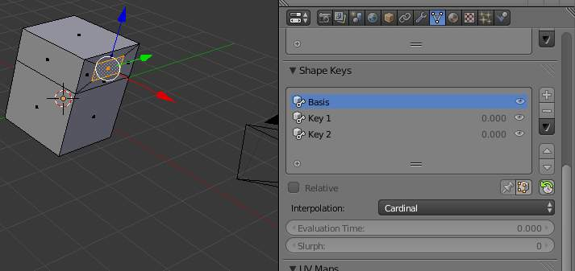
- Select shape key Basis to edit the first shape key.
- Select the extruded size face and S 0.5 LMB, then G X Minus1 LMB.
- Switch to Object Mode.
- Drag the Evaluation Time slider to make its value vary from 10 to 30.
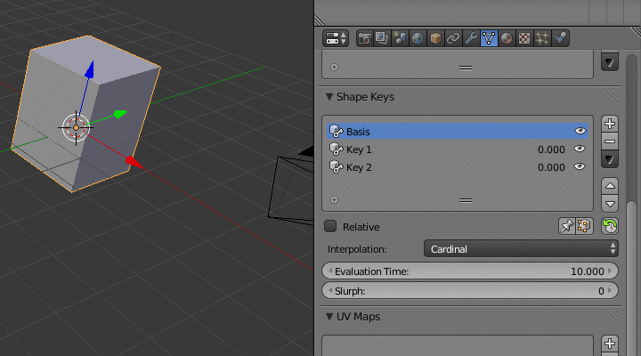

More Details On Absolute Shape Keys
The thing to remember about absolute shape keys is that they are incomplete until you click the Reset Timing button. When you create a shape key its “frame” property is zero (https://developer.Bforartists.org/T39897), which is a completely useless value. This frame value is not displayed on the UI so you can’t easily tell if something is wrong or screwy until your animation starts misbehaving.
The number displayed to the right of the key name is the value and is used in relative shape keys. It has no effect on absolute shape keys, so ignore it.
When you reset the timings Bforartists iterates through the shape keys assigning them frame values incrementing by 0.1 from key to key.
name | frame | evaluation time
Basis | 0.1 | 10
Key 1 | 0.2 | 20
Key 2 | 0.3 | 30
Key 3 | 0.4 | 40
If you delete a shape key this does not automatically alter the frame values assigned to remaining shape keys.
name | frame | evaluation time
Basis | 0.1 | 10
Key 1 | 0.2 | 20
Key 3 | 0.4 | 40

The Evaluation Time is how you choose which shape key is active, and how active it is. The interesting values range from 10 .. (n*10) where n is the number of shape keys. (assuming you have not deleted or added any keys since the last Reset Timing). If you are using shape keys for animation, 99% of the time you will be putting keyframes on this Evaluation Time field.
Remember: if you are having problems with your absolute shape keys, there is a good chance that you need to Reset Timing.

Shape Key Operators
3D View > Edit Mode > Header > Mesh > Vertices > Shape Propagate
Apply selected vertex locations to all other shape keys.
3D View > Edit Mode > Header > Mesh > Vertices > Blend From Shape
Blend in shape from a shape key.

Animating Cameras

These are some basic tools and properties animators may use for the camera.

Switching Cameras
Switching cameras is done with the Timeline operator ‘Bind Camera to Markers’.
The triangle above the camera will become shaded when active.
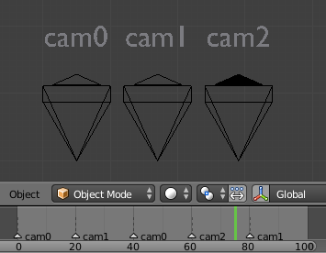
First in the Timeline, add a set of markers used to switch cameras. Press M to add marker, then Ctrl M to rename, duplicated markers should retain the same name.
- In the 3D View, select the Camera the Markers will switch to.
- In the Timeline, select the Marker(s) to switch to the Camera.
- In the Timeline, press Ctrl-B to Bind Cameras to Markers.

Moving Cameras

Move Along a Path
Sometimes its easier to move objects on path, see Moving Objects on a Path for more info.

Fly/Walk Modes
Fly/Walk Mode can be used in conjunction with the timeline record option.
To record your flight path as animation curves.

Lock Camera to View
Lock Camera to View can be used in conjunction with the timeline record option.
To record your view-port navigation as animation curves.

Dolly Zoom
The camera has a set of properties and tools via the Properties Editor.
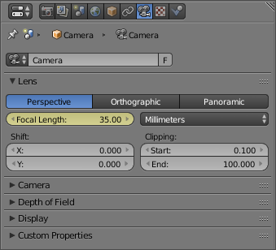
While the camera is moving towards an object the Focal Length property can be decreased to produce a Dolly Zoom camera effect, or vice versa.

Moving Objects on a Path

To make objects move along a path is a very common animation need. Think of a complex camera traveling, a train on his rails - and most other vehicles can also use “invisible” tracks! -, the links of a bicycle chain, etc. All these movements could obviously be done with standard Ipo curves, but this would be a nightmare! It’s much more easy and intuitive to define a path materializing the desired movement, and make your object(s) follow it.
Bforartists features you two different constraints to make an object follow a path, which have different ways to determine/animate the position of their owner along their path.
In Bforartists, any curve object can become a path. A curve becomes a path when its Path Animation button is enabled in the Curve data panel, but you don’t even have to bother about this: once a curve is selected as target for a “path” constraint, it automatically is enabled.
You can also directly add a “path” from the Add ‣ Curve ‣ Path menu entry (in a 3D view). This will insert in your scene a three-dimensional NURBS curve. This is an important point: by default, Bforartists’s curve are 2D and won’t move on the Z axis. To turn a standard curve three-dimensional, enable its 3D button, in the same Curve and Surface editing panel.
One last curve property that is important for a path is its direction, which is, for three-dimensional ones, materialized by its small arrows. You can switch it with the Curve ‣ Segments ‣ Switch Direction menu entry (or W, 2).
For more on editing path/curves, see the modeling chapter.
Note
Shapes on Curves
If you would rather like to have your object’s shape follow a path (like e.g. a sheet of paper inside a printer), you should use the Curve Modifier

Parenting Method
Older versions of Bforartists did not have constraints to make an object follow a path. They used a different method (deprecated, but still available), based on parenting.
To use this method, select the object that will follow the path, then Shift select the curve, and use Ctrl-P to bring up the parenting menu. Choose Follow Path. The object will now be animated along the path.
The settings for the path animation are in the Path Animation panel of the Curve properties panel.
Frames
Defines the number of frames it takes for the object to travel the path.
Evaluation Time
Defines current frame of the animation. By default it is linked to the global frame number, but could be keyframed to give more control over the path animation.
Follow
Causes the curve path children to rotate along the curvature of the path.
Radius
Causes the curve path child to be scaled by the set curve radius. See Curve Extruding
Offset Children
Causes the animation to be offset by the curve path child’s time offset value, which can be found in its Animation Hacks section of the Object Panel.

The Follow Path Constraint
The Follow Path constraint implements the most “classical” technique. By default, the owner object will walk the whole path only once, starting at frame one, and over 100 frames. You can set a different starting frame in the Offset field of the constraint panel, and change the length (in frames) of the path using its Frames property (Curve and Surface panel).
But you can have a much more precise control over your object’s movement along its path by keyframing or defining a Speed animation curve for the path’s Evaluation Time attribute. This curve maps the current frame to a position along the path, from 0.0 (start point) to 1.0 (end point).
For more details and examples, see the Follow Path constraint page.

The Clamp To Constraint
Another method of keeping objects on a path is to use the Clamp To constraint, which implements a more advanced technique. To determine where along the path should lay its owner, its uses the location of this owner along a given axis. So to animate the movement of your owner along its target path, you have to animate some way (Ipo curves or other indirect animation) its location.
This implies that here, the length of the path have no more any effect - and that by default, the object is static somewhere on the path!
For more details and examples, see the Clamp To constraint page.

